SAEMS

Sepsis Standing Order

Self-Learning Packet

Katherine Tuttle
Saint Mary’s Hospital
October 2016

PURPOSE
The SAEMS Standing Order Training Packet has been developed to serve as a template for EMS provider training. The intent is to provide consistent and concise information to all providers practicing within the SAEMS Region. The content of this Training Packet has been reviewed by the Protocol Development and Review Sub Committee, and includes the specific standing order, resources and reference material, and instructions for completing the Training Packet to obtain continuing education credit. One hour of SAEMS continuing education credit may be issued following successful completion of the module.
OBJECTIVES
Upon completion of this learning module the participant will be able to:
- Differentiate between SIRS, Sepsis, Severe Sepsis and Septic Shock
- Identify and establish priorities of treatment
- Identify those patients who qualify for the SAEMS Sepsis Standing Order

INSTRUCTIONS
- Read the self-learning packet and any additional reference material necessary.
- Complete the attached posttest and return it to your supervisor or base hospital manager for continuing education credit

INTRODUCTION
Sepsis is the body’s toxic response to an infection. Left untreated it results in organ failure, shock and death.
The number of cases of sepsis has been increasing each year for the past decade. Sepsis mortality is estimated to be between 25 and 50%. As with other time sensitive, high mortality disease states, the early recognition and treatment of severe sepsis and septic shock have been shown to reduce morbidity and mortality. One important and time sensitive intervention for patients with sepsis is early delivery of intravenous fluids and advanced notification to the emergency department. Transport of critically ill patients to the emergency department is associated with improved early goal directed therapy (EGDT). Early goal directed therapy includes structured interventions such as fluids, vasopressors, steroids and antibiotics administered to the patient in time sensitive intervals. Studies show that delays in treatment result in increased mortality. Similarly, there is evidence to support the benefit of early treatment for infections. EMS is essential in the reduction of treatment delays and can improve early goal directed therapy for sepsis patients.
Sepsis can occur to anyone, at any time. Any type of infection that is anywhere in your body can cause sepsis, including infections of the skin, lungs, urinary tract, abdomen, or other body parts.

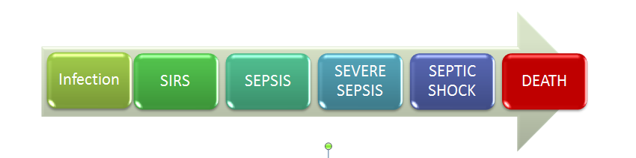
GENERAL

Incidence
There are approximately 1 million cases of sepsis in the United States each year. Sepsis kills someone in the United States every 2.5 minutes. Sepsis is the 10th leading cause of death in the United States. People over the age of 65 are 11 times more likely to die of sepsis. Anyone can get sepsis, however. For example, people who are immunocompromised, pediatrics, people with chronic illnesses, and people suffering from a severe burn or wounds. For every hour that passes without antibiotics, the mortality goes up by 8%. It is estimated that early recognition and treatment reduce mortality by 50%.
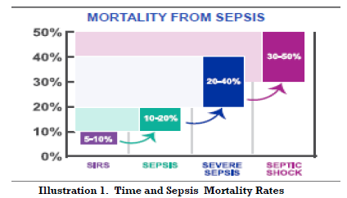

Pathophysiology
Inflammation and coagulation play large roles in the pathophysiology of sepsis. Sepsis results when an infectious insult triggers a localized inflammatory reaction that then spills over to cause systemic symptoms of fever or hypothermia, tachycardia, tachypnea, and either leukocytosis or leukopenia. These clinical symptoms are called the systemic inflammatory response syndrome (SIRS). Severe sepsis is defined by dysfunction of one of the major organ systems or unexplained metabolic acidosis. The inflammatory reaction is mediated by the release of cytokines, including tumor necrosis factor-alpha, interleukins and prostaglandins from neutrophils and macrophages. The cytokines activate the extrinsic coagulation cascade and inhibit fibrinolysis. These overlapping processes result in microvascular thrombosis. Thrombosis is one potential factor producing organ dysfunction. Activation of the coagulation system leads to consumption of endogenous anticoagulants (e.g., protein C and antithrombin). This may be an important factor in the development of microvascular coagulation. Anti-inflammatory mediators, as well as inflammatory mediators, have a role in sepsis and an excess of either can result in poor patient outcomes. Sepsis is a complex syndrome involving activation of a variety of systems.
http://www.ncbi.nlm.nih.gov/pubmed/11885412

SIRS is…
- Systemic Inflammatory Response Syndrome. SIRS has a set of objective identifiers:
Fever of more than 38°C (100.4°F) or less than 36°C (96.8°F)
Heart rate of more than 90 beats per minute
Respiratory rate of more than 20 breaths per minute or arterial carbon dioxide tension (PaCO ₂) of less than 32 mm Hg
Abnormal white blood cell count (>12,000/µL or < 4,000/µL or >10% immature [band] forms)

Sepsis is…
- Suspected or confirmed infection with 2 or more SIRS (systemic inflammatory response syndrome) criteria; (No organ dysfunction).
Severe Sepsis is …
- Suspected or confirmed infection with 2 or more SIRS criteria + any 1 organ system dysfunction (not chronic).
Severe Sepsis with hypoperfusion is …
- Suspected or confirmed infection with 2 or more SIRS criteria + Lactic Acid ≥ 4.0 and/or SBP < 90, MAP < 65 or 40 mmHg drop in systolic blood pressure from the patients baseline. BP responsive to IV fluids.
Septic Shock is …
Suspected or confirmed infection with 2 or more SIRS criteria and hypotension refractory to a minimum 30 ml/kg fluid bolus requiring vasopressors to improve blood pressure.

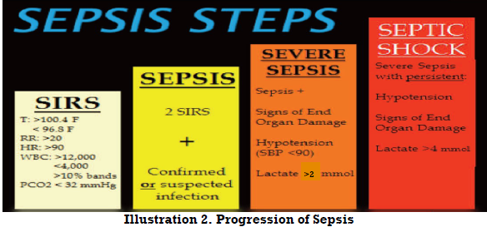

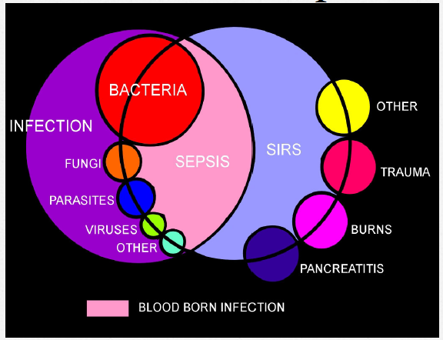

SEPSIS ASSESSEMENT
There is no one single sign or symptom of sepsis, rather it is a combination of symptoms. Think sepsis anytime you are evaluating your patient, especially anytime there is a change in mental status, vital signs or urinary output. Sepsis can start insidiously, so always keep it in mind.

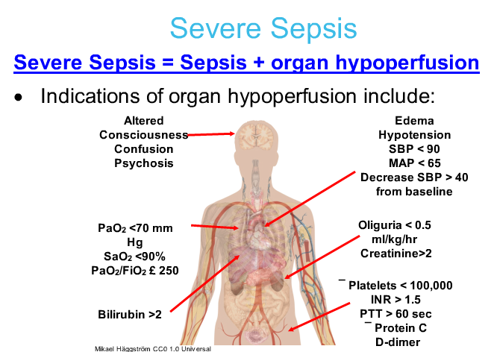

SEPSIS MANAGEMENT IN THE HOSPITAL
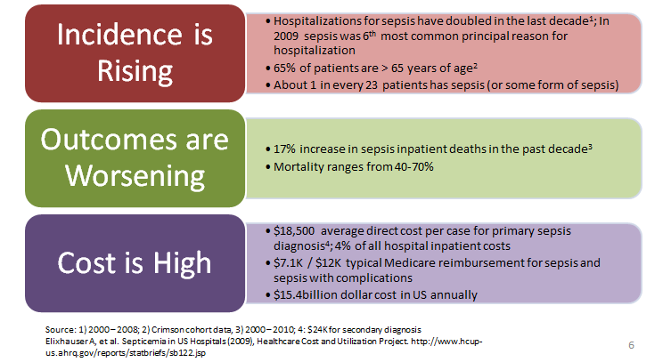
Hospitals will recognize sepsis and resuscitate based on their protocols. In general, it is usually a team approach with a structured process of checklists and “code team activations.” Unique to each hospital, hospital teams use early goal directed therapy (EGDT).
EGDT include:
- Fluid Resuscitation
  - As cytokine levels increase, the immune response causes massive vasodilation as well as a decreased systemic vascular resistance, resulting in hypotension. The goal of fluid resuscitation is to get enough fluid in the vasculature to increase the blood pressure enough to perfuse the vital organs. It is important to remember that unlike hypovolemic shock, septic shock does not need more oxygen carrying fluid. Isotonic fluids are adequate, especially in the initial phases of treatment, for increasing the blood pressure.
- Serum Lactate
  - Lactic acid is essential in identifying tissue hypoperfusion in patients who are not yet hypotensive, but who are at risk for septic shock.
- Blood cultures
  - Offers the best hope of identifying causative organisms.
- Administration of antibiotics
- Every 1 hour delay decreases the survival by 8%.
SEPSIS MANAGEMENT IN EMS
EMS can play an important and active role in recognizing sepsis.
Assess the patient for SIRS criteria. If the patient meets SIRS criteria, then evaluate for an infection, known or suspected. Look for common sources/sites for infection and physical exam findings.
Other diagnostic tools include:
- MAP (Mean Arterial Pressure)
  - MAP = DP + 1/3 PP.
DP is the diastolic pressure and PP is the pulse pressure. Most automated blood pressure cuff machines provide an MAP along with a blood pressure. MAPs are a better representation of overall perfusion to the vital organs of the body.
- EtCO₂
  - Is a continuous variable determined by basal metabolic rate, cardiac output and ventilation. Thus, abnormal levels may reflect derangement in perfusion, metabolism or gas exchange. Severe Sepsis is characterized by poor perfusion, leading to a buildup of serum lactate and resulting metabolic acidosis. EtCO₂ levels decline in the setting of both poor perfusion and metabolic acidosis. To compensate for metabolic acidosis, patients increase their minute ventilation. This increased respiratory rate “blows off” carbon dioxide and lowers EtCO₂. At the same time, poor tissue perfusion decreases the amount of blood flow to the alveoli of the lungs, reducing the amount of carbon dioxide that can be exhaled. Therefore, EtCO₂ is inversely proportional to lactate. As lactate levels rise in septic patients, EtCO₂ levels drop.

If an infection is known/suspected and the patient meets the SIRS criteria, then notify the hospital as soon as possible of your suspicions.

Follow the SAEMS Sepsis Standing Order:

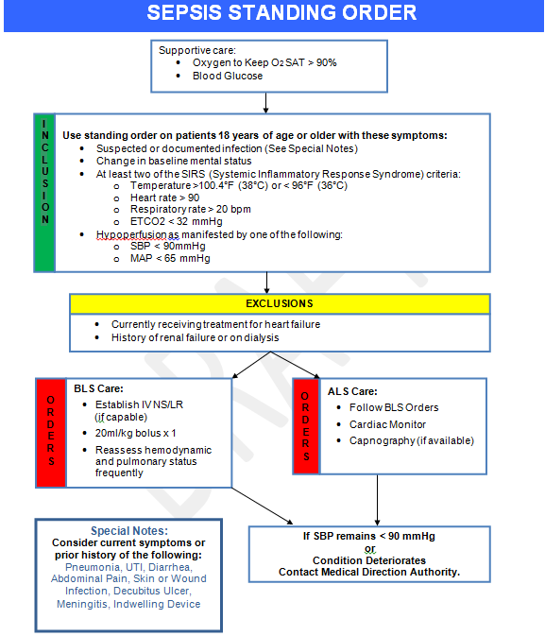

REMEMBER
Sepsis progression is … life threatening

Sepsis progression can lead to … organ failure, shock and death
Early recognition and treatment can … help to avert shock,
reduce mortality, morbidity and length of stay

Sepsis Post Test

NAME: ______________________ AGENCY: ________________ DATE: ______________

- Per the SAEMS Sepsis Standing Order, what is the correct amount of fluid bolus for a patient that you suspect sepsis?
  - 10ml/kg
  - 40ml/kg
  - 75ml/kg
  - 20ml/kg

- EtCO₂ is another diagnostic tool to identify sepsis because
  - As lactate levels rise in septic patients, EtCO₂ levels drop
  - EtCO₂ is a good indicator that fluid resuscitation is working
  - EtCO₂ helps the hospital decide what antibiotics are appropriate to use on a septic patient

- Early goal directed therapy (EGDT) involves structured interventions that include IV fluids, vasopressors, steroids and antibiotic administration to the patient in time sensitive intervals
  - True
  - False

- What are SIRS criteria?
  - Fever of more than 100.4F or less than 96.8F
  - Heart rate of more than 90 bpm
  - Respiratory rate of more than 20 bpm or ETCO₂ < 32mmHg
  - All of the above

- What is the definition of MAP
  - Mean atrium pressure which help diagnose cardiac output
  - Mean arterial pressure which gives a better representation of overall perfusion to the vital organs of the body
  - Mean arterial perfusion which help diagnose ejection fraction of the heart

- EMS is not essential in the reduction of treatment delays and cannot improve early goal directed therapy for sepsis patients
  - True
  - False
- You should consider sepsis in a patient with a history of or has current symptoms of
  - Pneumonia
  - Urinary tract infection
  - Indwelling device
  - Abdominal pain
  - All of the above

- You should suspect sepsis anytime there is a change in mental status, vital signs or urinary output
  - True
  - False

- Only elderly and pediatric patients can get sepsis
  - True
  - False

- Early recognition and treatment of sepsis can reduce mortality rates by
  - 8%
  - 30%
  - 50%
  - 60%

- The goal of fluid resuscitation is to
  - Lower the serum lactate levels
  - Get enough fluid in the vasculature to increase the blood pressure enough to perfuse the vital organs
  - To help increase EtCO₂

- A 35 year old female calls 911 for lower abdominal pain. She has recently been diagnosed with an UTI and has taken her full prescription of antibiotics. She is pale and diaphoretic, HR is 115, Blood pressure 91/40 and respiratory rate is 30. Does this patient meet sepsis criteria?
  - Yes
  - No

- The wife of a 72 year old male calls 911. He has been complaining of shortness of breath, cough and fever for the last 2 days. This morning when he woke up, the patient was confused and pale. The wife stated he did not urinate this morning. His vital signs are BP of 72/30, HR of 130, respiratory rate of 30, Temp of 101.2 F, MAP = 45 and EtCO₂ of 25 mm Hg. Does this patient meet the sepsis criteria?
  - Yes
  - No

